Battlemoor SCORES Pre-Registration Instructions

When using SCORES to register for an event, you must log into your online SCA membership account, or create a new profile if you do not have one. Once that is completed, you can register for the event.

1. Enter the number of tickets you are purchasing in the “Quantity” box.

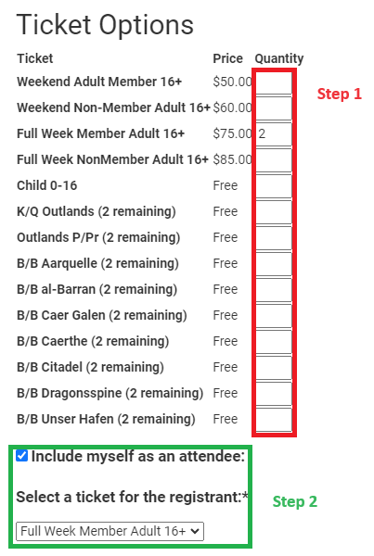

2. If you are including yourself at an attendee, make sure the box is selected, and then select a ticket you are using for yourself in the dropdown and click “Continue.”

3. If you have other persons associated with your membership account, the screen below will allow you to assign a ticket to those individuals. For each person that you are registering for the event, you must 1) check the box next to the name you wish to assign tickets to; then 2) Use the dropdown box to assign a ticket. PLEASE NOTE: If you purchased 2 of the same type of ticket and assigned a ticket to yourself in the previous step, your assigned ticket will have a “(1)” in the dropdown box (example below). You need to assign a ticket without “(1)” to those others listed in your account. Once complete, click “Continue.”

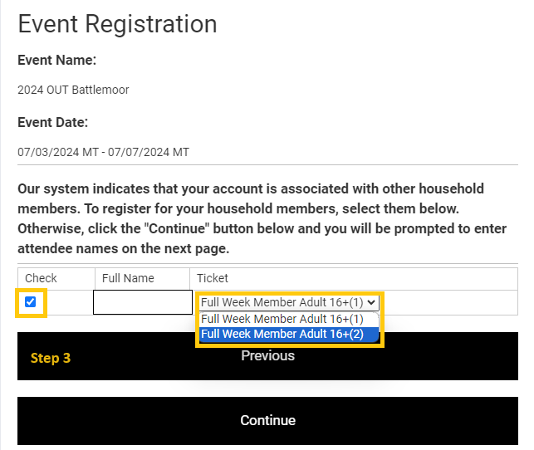

4. On the next screen, you may choose to pre-purchase merchandise. Each ticket will allow you to select multiple items from the list and the drop-down boxes will allow you to purchase up to two of each item (i.e. “Purchase One T-Shirt” or “Purchase Two T-Shirts”). Once your selections are made, click “Continue.”

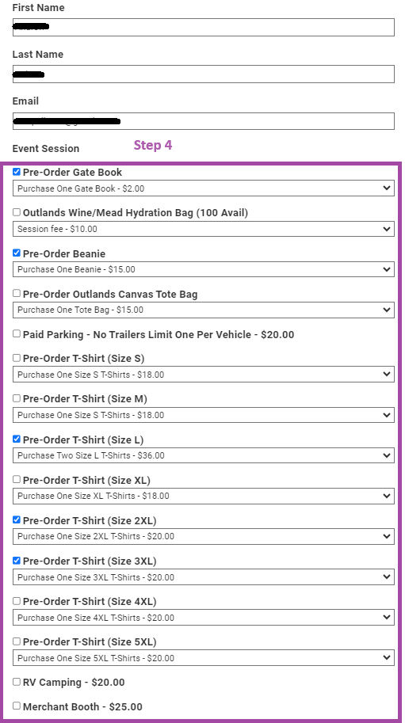

5. The next screen will allow you to verify the tickets and items you are purchasing. You may click “Previous” if you need to amend your selections. Once you have verified the tickets and items, click “Continue.”

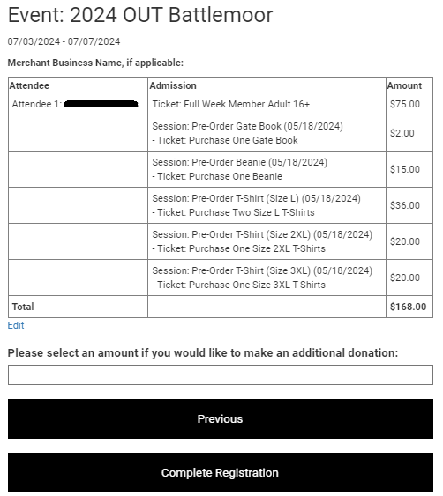

6. Select your payment method (Credit Card, E-Check, or PayPal) and click “Submit.”

